1. Create sample classes to understand boxing & unboxing.

Auto Boxing

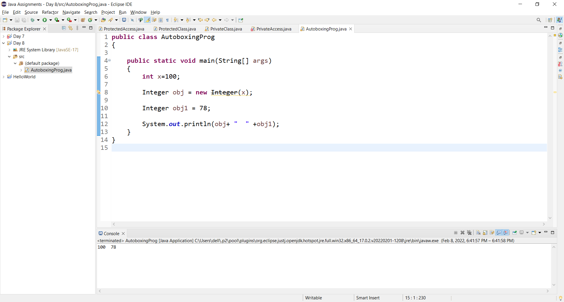

Auto Unboxing:

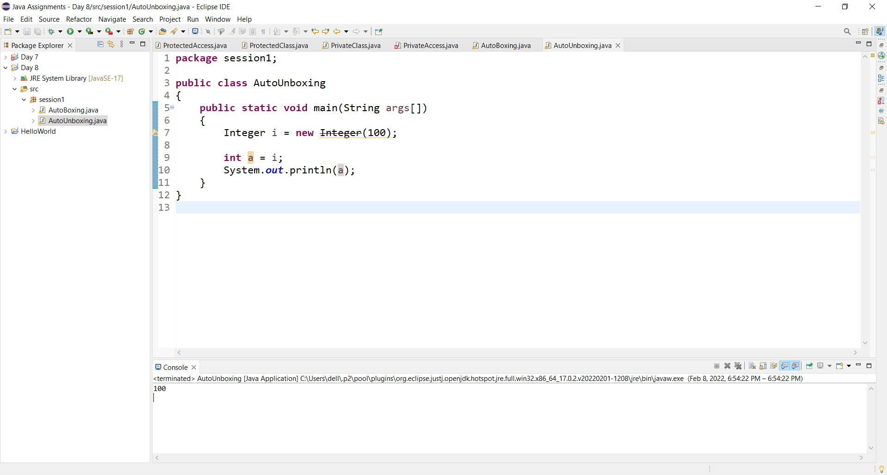

1. Use different methods of java defined wrapper classes.

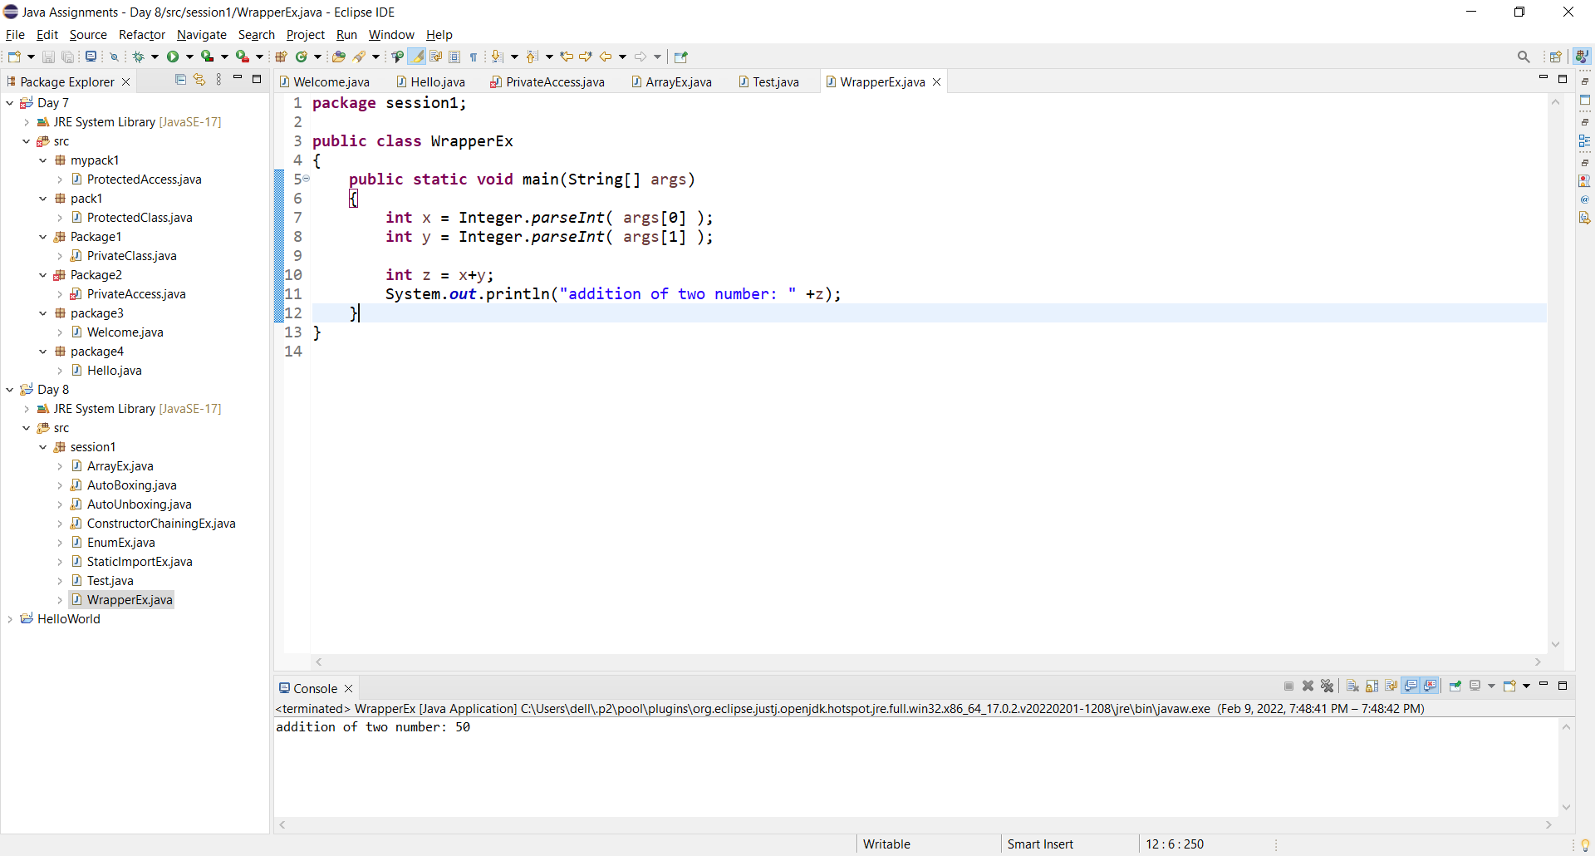

1. create a class and convert all primitive datatypes into wrapper classes.

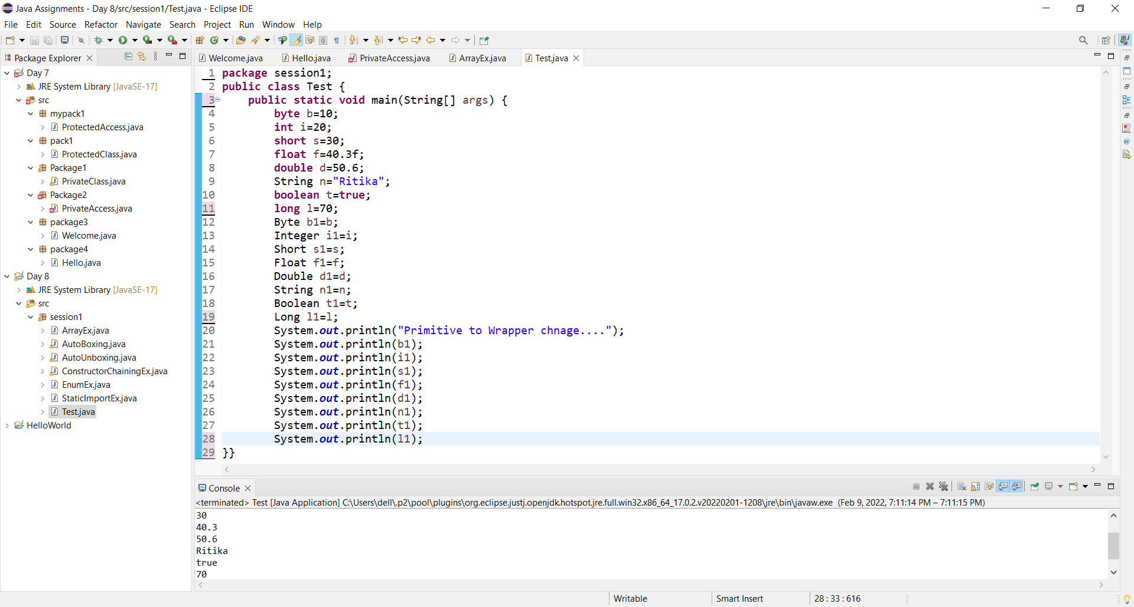

1. create an Enum Class define enum inside class traverse it.

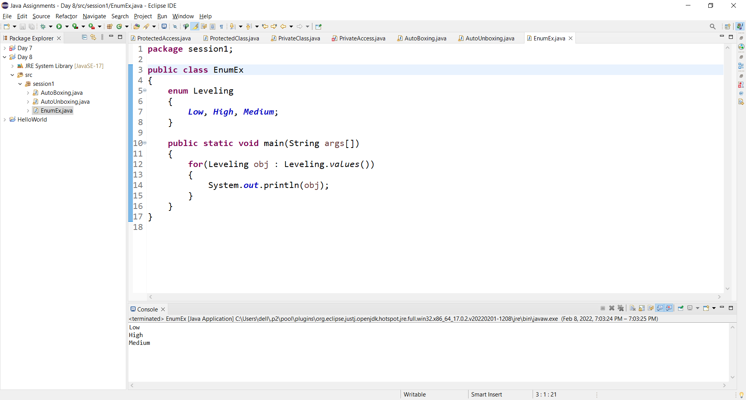

1. Create a class ArrayEx and sort the elements by using ArraySort method.

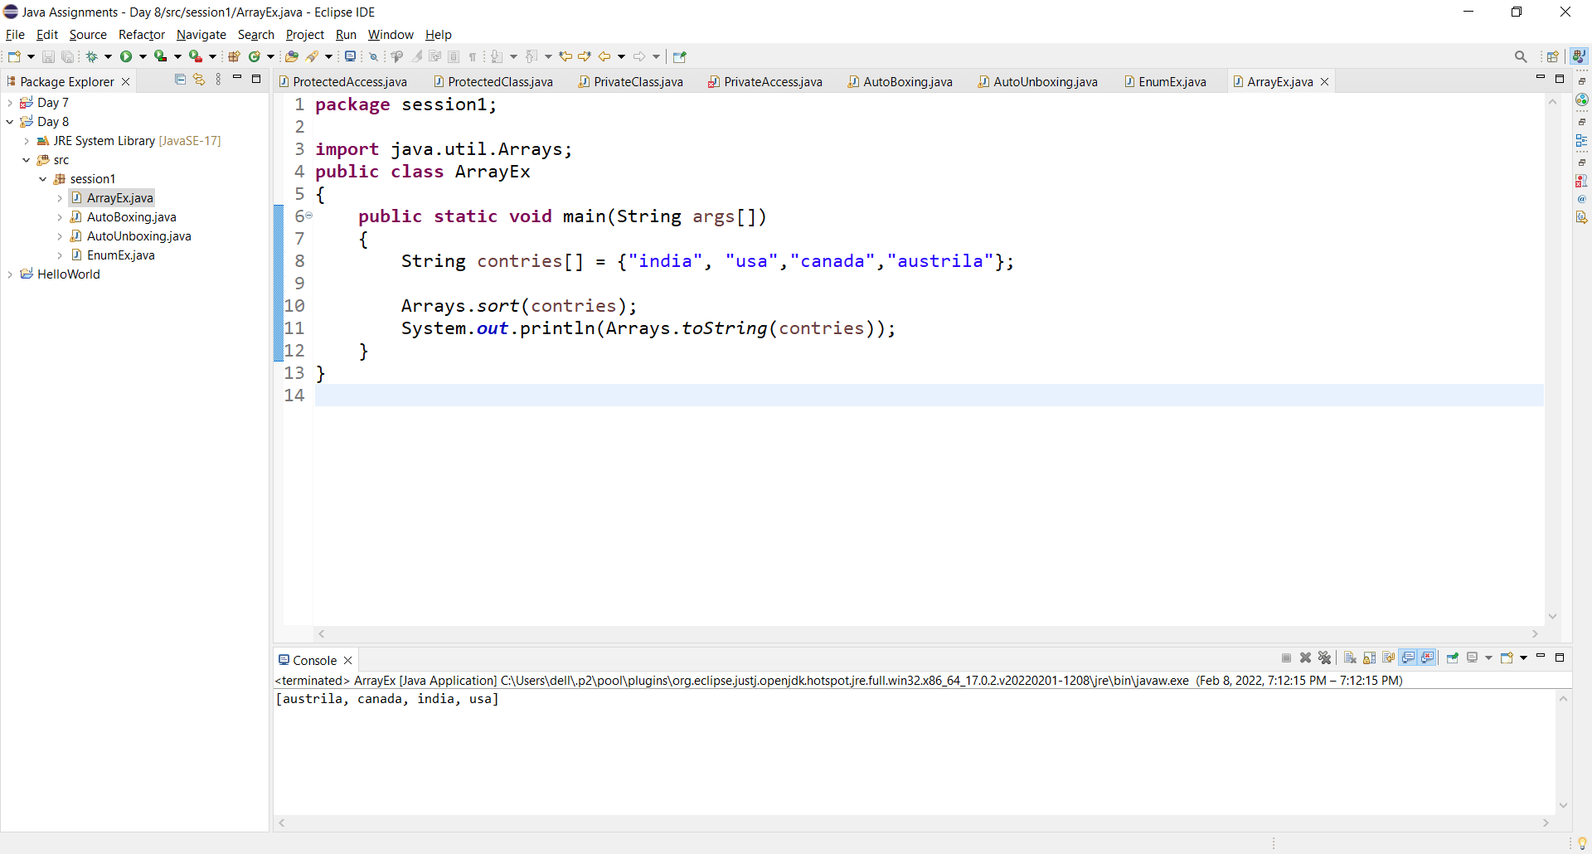

1. Create a class and apply static import package into that class

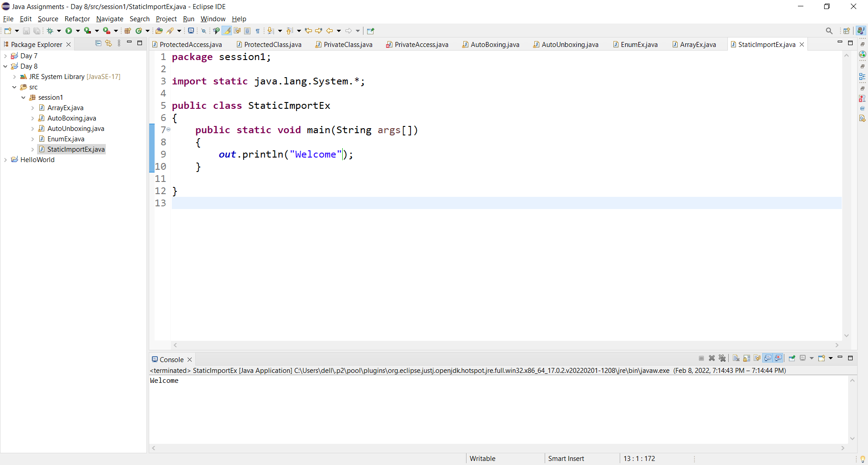

1. Create a class and create default and param constructor and create constructor chaining.

